
Inter-Kingdom Equestrian Competition

Anno-Soceitatus Fifty Two

IKEqC Login Credentials

Greetings Council Member! There are three logins for which you will need to be aware of. Two of these logins will be up to you to set strong passwords for, and provide means to recover them. The third is assigned by Sandor, because it is for a shared account that any Council member may access and send official communications from.
Table of Contents
IKEqC General Email box 2
From the web: 2
From a Email Client (Outlook, Mail, Thunderbird): 3
IKEqC Blogs: 4

IKEqC General Email box
This email account is for receiving communications in an official manner, and to respond in an official manner. Any Council member may access, review, forward, reply, or send emails to and from this address. When sending email from this account, please sign your emails so that the recipients know who is communicating officially with them.

From the web:
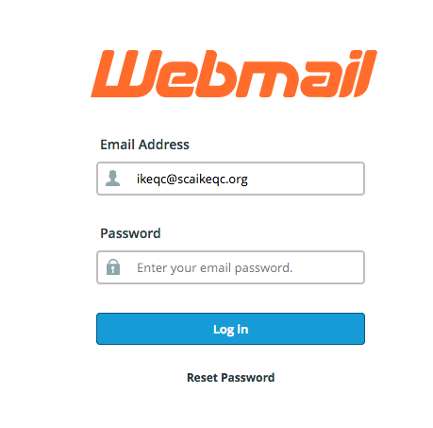
Go to this web address, “https://scaikeqc.org:2096”. The first time you go there your browser will give you a security warning. I have not yet invested in a SSL certificate as they are a bit expensive. You will need to “continue to this site” or “add an exception” through the Advanced button in order to access this page. You will only need to do this once per machine.
You will then be presented with this screen prompt:
You will enter “ikeqc@scaikeqc.org” in the Email address box, and the password in the password box. For security reasons the current password will be provided to you in a separate message. For your convenience you may print out this document and record the password here:

From here you may use the email system’s own help system to learn how to use the software, though its use should be self explanatory.

From a Email Client (Outlook, Mail, Thunderbird):
Use the following information to configure your client:
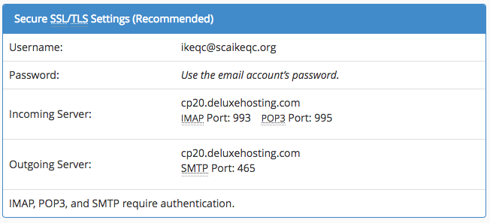
You may receive security warnings about the SSL Cert being self-signed, this can be safely ignored.
In addition, be sure to set your email client to NOT DELETE emails that have been read.
If your ISP does not permit you to use SMTP servers other than theirs, use the web client to send any messages.

IKEqC Blogs:
The IKEqC Webpage actually has two blogs, both running WordPress. One is for generating articles and sharing images with the knowne worlde, and the other just for the IKEqC Council.
You will be provided with a username that will apply to both of these blogs, and your initial password will be the same as the current IKEqC General Email box password.
The IKEqC Blog, http://blog.scaikeqc.org, is the public one, the most recent post is displayed on the main page with the top 5 scores.
The IKEqC Admin Blog, http://scaikeqc.org/adm, is the private Council-Only one, where Event and Practice details are sent in via the reports@scaikeqc.org email address this includes the images of the scoresheets for the Events and Practices.
The means to login is similar for both sites.
To login to the public blog, go to this web address: “http://scaikeqc.org/blog/wp-admin”.
To login to the private blog, go to this web address: “http://scaikeqc.org/adm/wp-admin”.
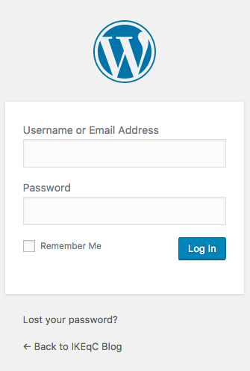
Once there you will be presented with a login screen:
You need to use your username on the first time you log in, and after you have setup your user details you can use your email address afterwards.
The email address you choose will be the one where notices of new content will be sent.
The password is initially set to the current IKEqC General Email box password, it is up to you to set a new password when setting up your user account.
Also, from this page, should you need to reset your password you may request a reset link to be sent to your email by following the “Lost your password?” link.
There are a number of places you can learn about WordPress and how to use it, but if you have specific problems please let Sandor know and he will do his best to help you.

